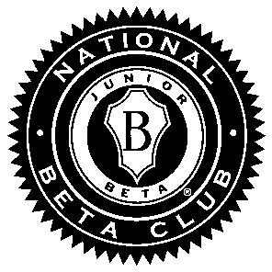
Dresden Middle School Beta Club

Membership Information Sheet
The DMS Beta Club is a local chapter of The National Beta Club. The National Beta Club is an organization that provides students with many opportunities such as leadership academies, conventions, and scholarship programs. The sponsors for our club are: Mrs. Mindy Thomas, Mrs. Katie West, and Mrs. Rhiannon Coleman – membership, meetings, and service hours; Mrs. Leigh Hart – Lions’ Den; and Mrs. Jamie Rickman – convention.
Membership Requirements and Benefits:
- Students with a 90 or above average in each subject for a semester are asked to join.
- There is a $25 membership fee.
- Active Members must maintain a 90 or above average each marking period and can have no individual subject grade less than 85. Any student failing to maintain this standard is given 1 marking period to improve his/her grades. During that marking period, the member is considered to be “on probation”. If at the end of the probation period, the member meets expectations, he/she has full membership reinstated. If not, membership is suspended.
- The motto of The National Beta Club is “Let Us Lead by Serving Others”; therefore, all members are expected to complete service hours each year. At this time, the minimum number of hours required is five per year. Service hours can include volunteering at school, a nursing home, church, charity organization, etc. We will also accept hours dedicated to helping individuals; however, service credit will not be given for any of the following: any work for which someone is paid or works done for a family member, fundraisers, etc. When in doubt, please ask a sponsor. The deadline to return paperwork for credit is the first school day of each month. For example, any service hours completed in January must be recorded on the official service form, signed and returned by February 1. Upon returning to school after summer vacation, students are given two weeks to complete and return paperwork for hours completed in May, June, or July. Sponsors reserve the right to disallow hours due to the following: paperwork deadline missed, paperwork not completed correctly, paperwork not signed by supervising individual or inappropriate activities.
- There are meetings that members are expected to attend. Mrs. Thomas, Mrs. West and Mrs. Coleman will announce the dates and times of those meetings. Students with an excused absence from school will be excused from those meetings. All student meetings will be held sometime during the school day.
- Our club attends the state convention each year. Members are not required to attend; however, those who go attend meetings, participate in competitions and get to meet Betas from across the state of Tennessee. The two days of school that are missed are not considered as absences; however, students are responsible for work assigned during these two days.
- The Lions’ Den is a Beta Club sponsored activity in our school. Beta members help organize, run and raise money for The Lions’ Den.
- All 8th grade members, who complete middle school in good standing, are recommended for membership in high school Beta.
- Beta website that provides Beta members with fun activities (www.betaclub.org).

